INFORMATICS INSTITUTE OF TECHNOLOGY

In Collaboration with

ROBERT GORDON UNIVERSITY ABERDEEN

**Crop Disease and Pests Detection with Agricultural Community forum using Image Processing Techniques**

A Requirement Specification Document by

Runisi Nikoya Samaranayake – 20221247

Damitha Udara Weerasinghe – 20210669

Seth Nimthaka Rajarathne – 20211344

Yasini Mandara Karunanayake 20221151

Supervised by

Ms. Kalhari Walawage

Submitted in partial fulfilment of the requirements for the BEng/BSc in <Insert the nomenclature of the degree> degree at the Robert Gordon University.

**November 2023**

© The copyright for this project and all its associated products resides with Informatics Institute of Technology

**SOFTWARE REQUIREMENT SPECIFICATION**

# 1.1 CHAPTER OVERVIEW

This chapter analyses the technique for gathering system requirements as well as the measures required to assess the data gathered during the process. Stakeholder analysis is shown by presenting a description of their obligations to the system. There are several approaches for analysing the needs collected, which are then emphasized by outlining the advantages and disadvantages of each strategy chosen. The requirement analysis part also includes a use case diagram with additional details. Finally, a scope description is used to characterize and prioritize the system's functional and non-functional demands.

# 1.2 RICH PICTURE

# 1.3 STAKEHOLDER ANAYLYSIS

The onion diagrams depict the system's established stakeholders, as well as an overview of the system and the stakeholder's place within it.

## 1.3.1 ONION MODEL

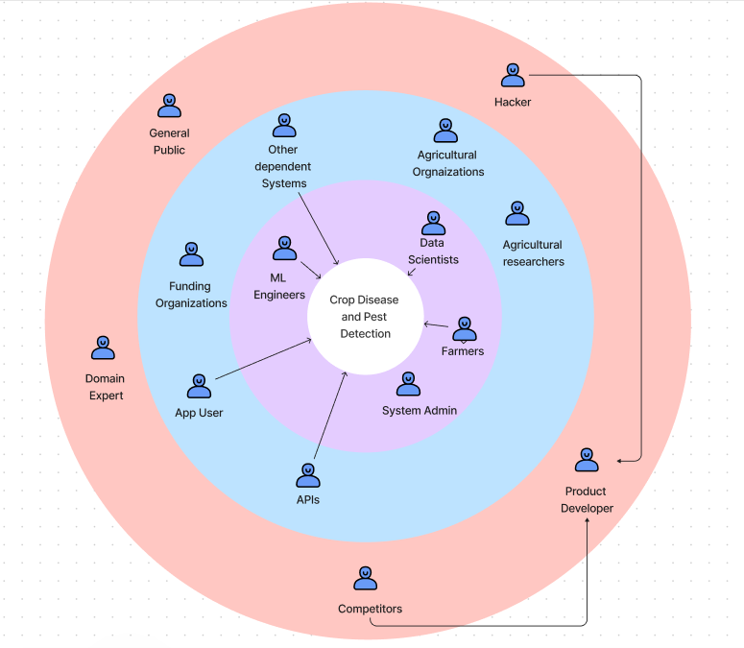

## 1.3.2 STAKE HOLDER VIEW POINTS

|  |  |  |
| --- | --- | --- |
| Stake Holder | Roles | Benefits |
| **System** | | |
| Data Scientists  ML Engineers | Operational Maintenance | Design the Crop Disease and Pest detection model and implementing them |
| Farmers | Functional Benificiary | Access more effective tools for early disease and pest identification. |
| System Admin | Operational Administration | Maintain and handle the project’s IT infrastructure. |
| **Containing Environment** | | |
| Agricultural Organizations | Quality Benificiary | Make sure if the application is of high quality and provide resources and support for the project. |
| Agricultural  Researchers | Educational Beneficiary | Assess the present accessible systems and come up with plausible solutions that will enhance current processes and procedures. |
| APIs  Other dependent systems  App user | Functional Beneficiaries | Uses the developed apps in a variety of situations or integrates them with various other systems. |
| Funding Organization | Financial Beneficiaries | They are the shareholders of the whole system |
| **Wider Environment** | | |
| Public | Positive | Provides information on improving agricultural productivity and provides feedback on the systems strategies. |
| Domain Expert | Expert | Provides a domain perspective on the project's technology and techniques, as well as determining if the implementation plan is practical. |
| Product Developer | Developer, Operational Maintenance | System development and maintenance |
| Hacker | Negative Stakeholder | Unauthorized access to the application and its information in order to change the application's data or contents. |
| Competitor | Negative Stakeholder | Creates a competing application with characteristics comparable to the proposed system, offering prospective market rivalry. |

# 1.4 SELECTION OF REQUIREMENT ELICITATION TECHNIQUES

This section examines and assesses several ways of acquiring system needs, such as monitoring existing systems, surveys, questionnaires, and interviews.

## 1.4.1 OBSERVING SYSTEMS AND LITERATURE REVIEW

The first phase of the requirement elicitation is to review existing systems, where current work in the domain is reviewed to discover and enhance essential characteristics.

|  |  |
| --- | --- |
| ADVANTAGES | DISADVANTAGES |
| * Helps to identify the limitations and feature gap in the current existing work. * Helps to identify the process and the main components of the disease and pests detection system | * Reviewing existing systems is complex due to the diverse objectives of different researchers. |

## 1.4.2 SURVEYS AND QUESTIONNAIRE

Farmers who are the target stakeholders will be polled to acquire important project specifications and suggestions on the proposed system.

|  |  |
| --- | --- |
| ADVANTAGES | DISADVANTAGES |
| * Requires less time for the participants to answer the questions * Gathered data can be analysed and done easily | * The questionnaire filled by the participant may misunderstand the question * The examination of the data would become complicated if participants did not provide the expected responses. |

## 1.4.3 INTERVIEWS

Due to their extensive knowledge of the agricultural area, researchers, academics, industry experts, and professionals in agriculture were the target audience for individual interviews.

|  |  |
| --- | --- |
| ADVANTAGES | DISADVANTAGES |
| * Directly interacting with the audience is really efficient * Direct conversation with the interviewer makes it possible to resolve any doubts right away, which improves communication efficacy. | * The answers provided by the interviewees might not be straightforward * Covering a large number of audiences is difficult and time consuming. |

# 4.5 DISCUSSION OF RESULTS

We were able to verify the stated limitations and get their feedback on the development of a mobile application for crop disease and pest identification by interacting with the main stakeholders, the farmers, using questionnaires in both Sinhala and English.

# 4.6 SUMMARY OF FINDINGS

|  |  |  |  |
| --- | --- | --- | --- |
| Findings | Literature Review | Questionnaire | Interviews |
| There aren't many applications around the world available for crop disease and pest detection. |  |  |  |
| It is more effective to use CNN for image processing techniques |  |  |  |
| The application should offer practical and quick means of delivering expert assistance, solutions, and feedback. |  |  |  |
| Lack of datasets available for both diseases and pests of crops |  |  |  |
| Most of the existing systems does not have both a community forum including an integrated bot. |  |  |  |

# 1.7 CONTEXT DIAGRAM

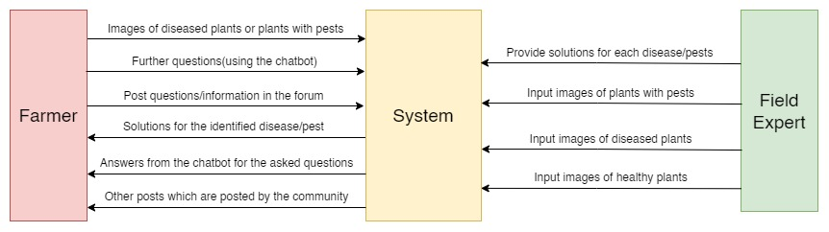

# 1.8 USE CASE DIAGRAM

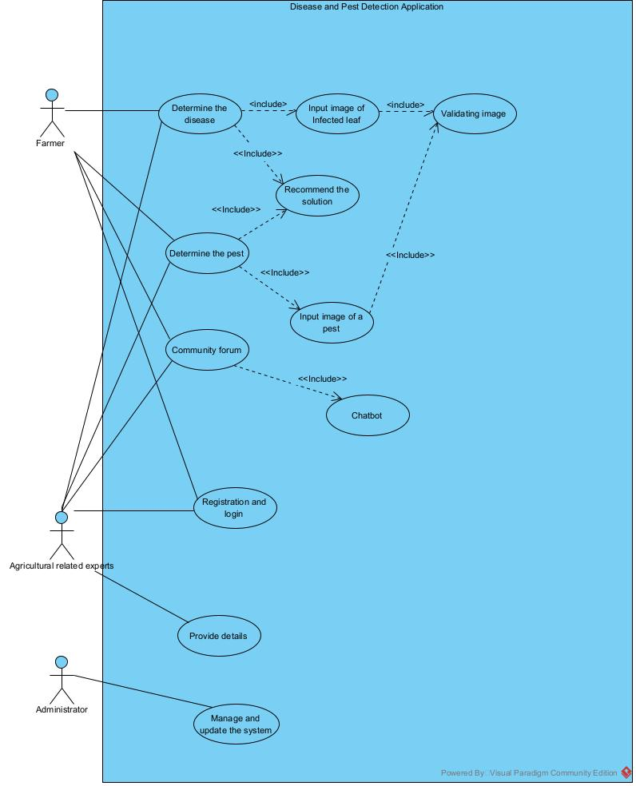

## 1.8.1 USE CASE DESCRIPTIONS

|  |  |
| --- | --- |
| Use case Id | UC001 |
| Use case name | To determine the disease and pest |
| Actors | Farmer, Agricultural related experts |
| Purpose | To identify the name of the crop disease |
| Overviews | Farmer uploads the image to the application in order to determine the disease of the crop and generates the result |
| Pre - Conditions |  |
| Post - Conditions | Determining the disease and providing necessary solutions |
| Main flow | Farmer – 1) Farmer uploads an image of the leaf  System – 1) The application will generate the relevant disease of the image uploaded |
| Alternative flow | Healthy leaf |
| Exceptional flow | 1. Uploaded file is not a recognized image format 2. system crashes during the process. 3. Displays an error message to the farmer 4. Encourage user to refresh the page |

|  |  |
| --- | --- |
| Use case Id | UCOO2 |
| Use case Name | Community forum |
| Actors | Farmer, Agricultural expert |
| Purpose | Farmers can use this forum to encourage information exchange, networking, and cooperative solutions to agricultural problems by fostering knowledge sharing, problem solving, and community building among farmers and agricultural specialists. |
| Overviews | Farmer or any expert will enter the query and the forum will provide the results |
| Pre - Conditions | Farmers should have a problem to discuss |
| Post - Conditions | Problem is solved |
| P | Farmer – 1) Farmer or any expert provides a query in the forum  System – 1) Provides the results |
| Alternative flow | Farmer has no problems |
| Exceptional flow | 1. Spam and inappropriate content 2. Technical issues 3. Farmers questions or problems being not solved 4. Receiving inaccurate information |

# 1.9 FUNCTIONAL REQUIREMENTS

The systems functional requirements are listed in the table below, along with their priority level.

|  |  |  |
| --- | --- | --- |
|  | **Requirement and Description** | **Priority** |
| FR-01 | Capture image | Critical |
| *The system allows the user to take images* |
| FR-02 | Accepting images taken | Critical |
| *As an input, the app must be able to accept images taken* |
| FR-03 | Community Forum | Critical |
|  | *enhance communication and information exchange between farmers and agricultural specialists.* |  |
| FR-04 | Chatbot Assistance | Critical |
|  | *Incorporate a chatbot function to offer farmers individualized support by responding to their queries regarding pests and crop diseases.* |  |
| FR-05 | Isolating the diseased part of the plant | Critical |
| *It's important to separate the diseased component of the plant in order to stop the healthy portions from deceiving or interacting with the tool.* |
| FR-06 | Generate evaluation results to the model | Critical |
| *Accuracy and performance evaluation are essential features for research, even though they are not crucial functions for end users.* |
| FR-07 | Support different qualities of images | Non-  Critical |
| *The quality of the image should be varied, due to users having different types of phones.* |
| FR-08 | GUI and other Interface support | Critical |
| *User friendly UI and API interfaces to connect with the system* |
| FR-09 | Produce Result | Critical |
| *produce outcomes based on image processing.* |

# 1.10 NON-FUNCTIONAL REQUIREMENTS

**Accuracy**

Accuracy is really important for this system, as disease and pests should be correctly identified according to the image captured and recommend the correct solutions to the farmers.

**Performance**

The dataset of train and test set is very large and will increase with time therefore model training time will be longer.

**Usability**

Command prompt may be used to control the entire system; however, to improve the tool's user-friendliness, a stored image from the phone can be uploaded.

**Security**

The system needs to be protected in order to prevent unauthorized access and data exploitation, since users are required to log in using their username and password.

|  |  |  |  |
| --- | --- | --- | --- |
|  | Requirement and Description | Specification | Priority |
| NFR - 01 | The model's accuracy should be quite good. | Accuracy | Important |
| NFR - 02 | Image processing for treatment recommendation should not take too lengthy. | Performance | Important |
| NFR - 03 | The procedure should be carried out with as little hardware as possible. | Performance | Important |
| NFR - 04 | User friendly interface for image uploading | Usability | Non-  Important |
| NFR - 05 | User data should be secured to prevent authorized access | Security | Non-  important |
| NFR - 06 | It should be possible to expand the hardware configuration. | Scalability | Non-  Important |

# 1.11 CHAPTER SUMMARY

An informative synopsis of the Software Requirement Specification (SRS) is given in this section. It goes into detail on identifying the important project stakeholders and how involved they are. In addition, it provides an overview of the techniques employed in requirement elicitation, summarizes the conclusions, and provides a brief overview of the insights that were found. It also includes creating priority lists for functional and non-functional criteria, making sure that crucial facets of the software's development are suitably highlighted and taken care of.